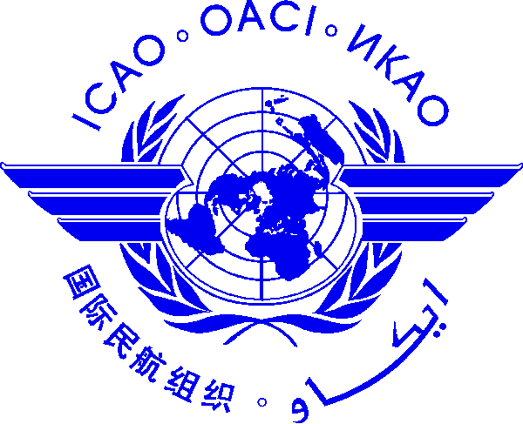 |  | International Civil Aviation Organization  Cooperative Development of Operational Safety and Continuing Airworthiness Programme (COSCAP)  Beijing, China  □ Recurrent Training on the ICAO Technical Instructions, 9 to 11 January 2017  □ Recurrent Dangerous Goods Safety Oversight Workshop, 12 to 14 January 2017  Bangkok, Thailand  □ Recurrent Training on the ICAO Technical Instructions, 16 to 18 January 2017  □ Recurrent Dangerous Goods Safety Oversight Workshop, 19 to 21 January 2017  After completing, please submit to:  E-mail: sun.qun.susan@coscap-icao.org; khun.nong@coscap-icao.org  Fax International: +86 10 8402 4554 (China); +66 2 287 0805 (Thailand)  Please select one training location and register by 23 December 2016

Nomination Form [please type or print]

State/ Organization
Name | Title |  | Family name (capitals) | First name | Middle initial
□ Mr.:
□ Ms.:
□ Other:
Official Position
Mailing Address
Telephone (office)
Fax
(office)
E-mail
Hotel
Date

NOTE: Participants are expected to make their own hotel and visa arrangements.

